# Install UiPath:

1. Go to <https://www.uipath.com/developers/studio-download>
2. Fill in the form
3. Download the UiPath Studio Installer
4. Start the Installer

It should be quick, and you don’t need to do anything else.

# Connect UiPath to the Orchestrator:

1. Click on the UiPath assistant logo



1. Click on “Preferences”



1. Click on “Orchestrator settings”
2. In “Service URL”, put the link to the orchestrator: <https://cloud.uipath.com/capgeminihr>.
3. Click sign in.
4. If asked, fill in login and password.

# Start the bot:

1. Click on the UiPath assistant logo



1. You should see the compesnsation process

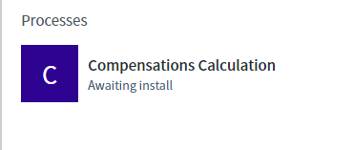

1. Click on the run button to launch the bot

# Files Locations:

1. Clarity extracts should be put in: C:\Compensations\1. Input\1. Clarity Extract
2. Work regime files should be in: C:\Compensations\1. Input\2. Work Regimes
3. Historical data files can be found in: C:\Compensations\1. Input\3. Historical Data
4. The output files can be found in: C:\Compensations\2. Output

If those folders do not exist, please create them